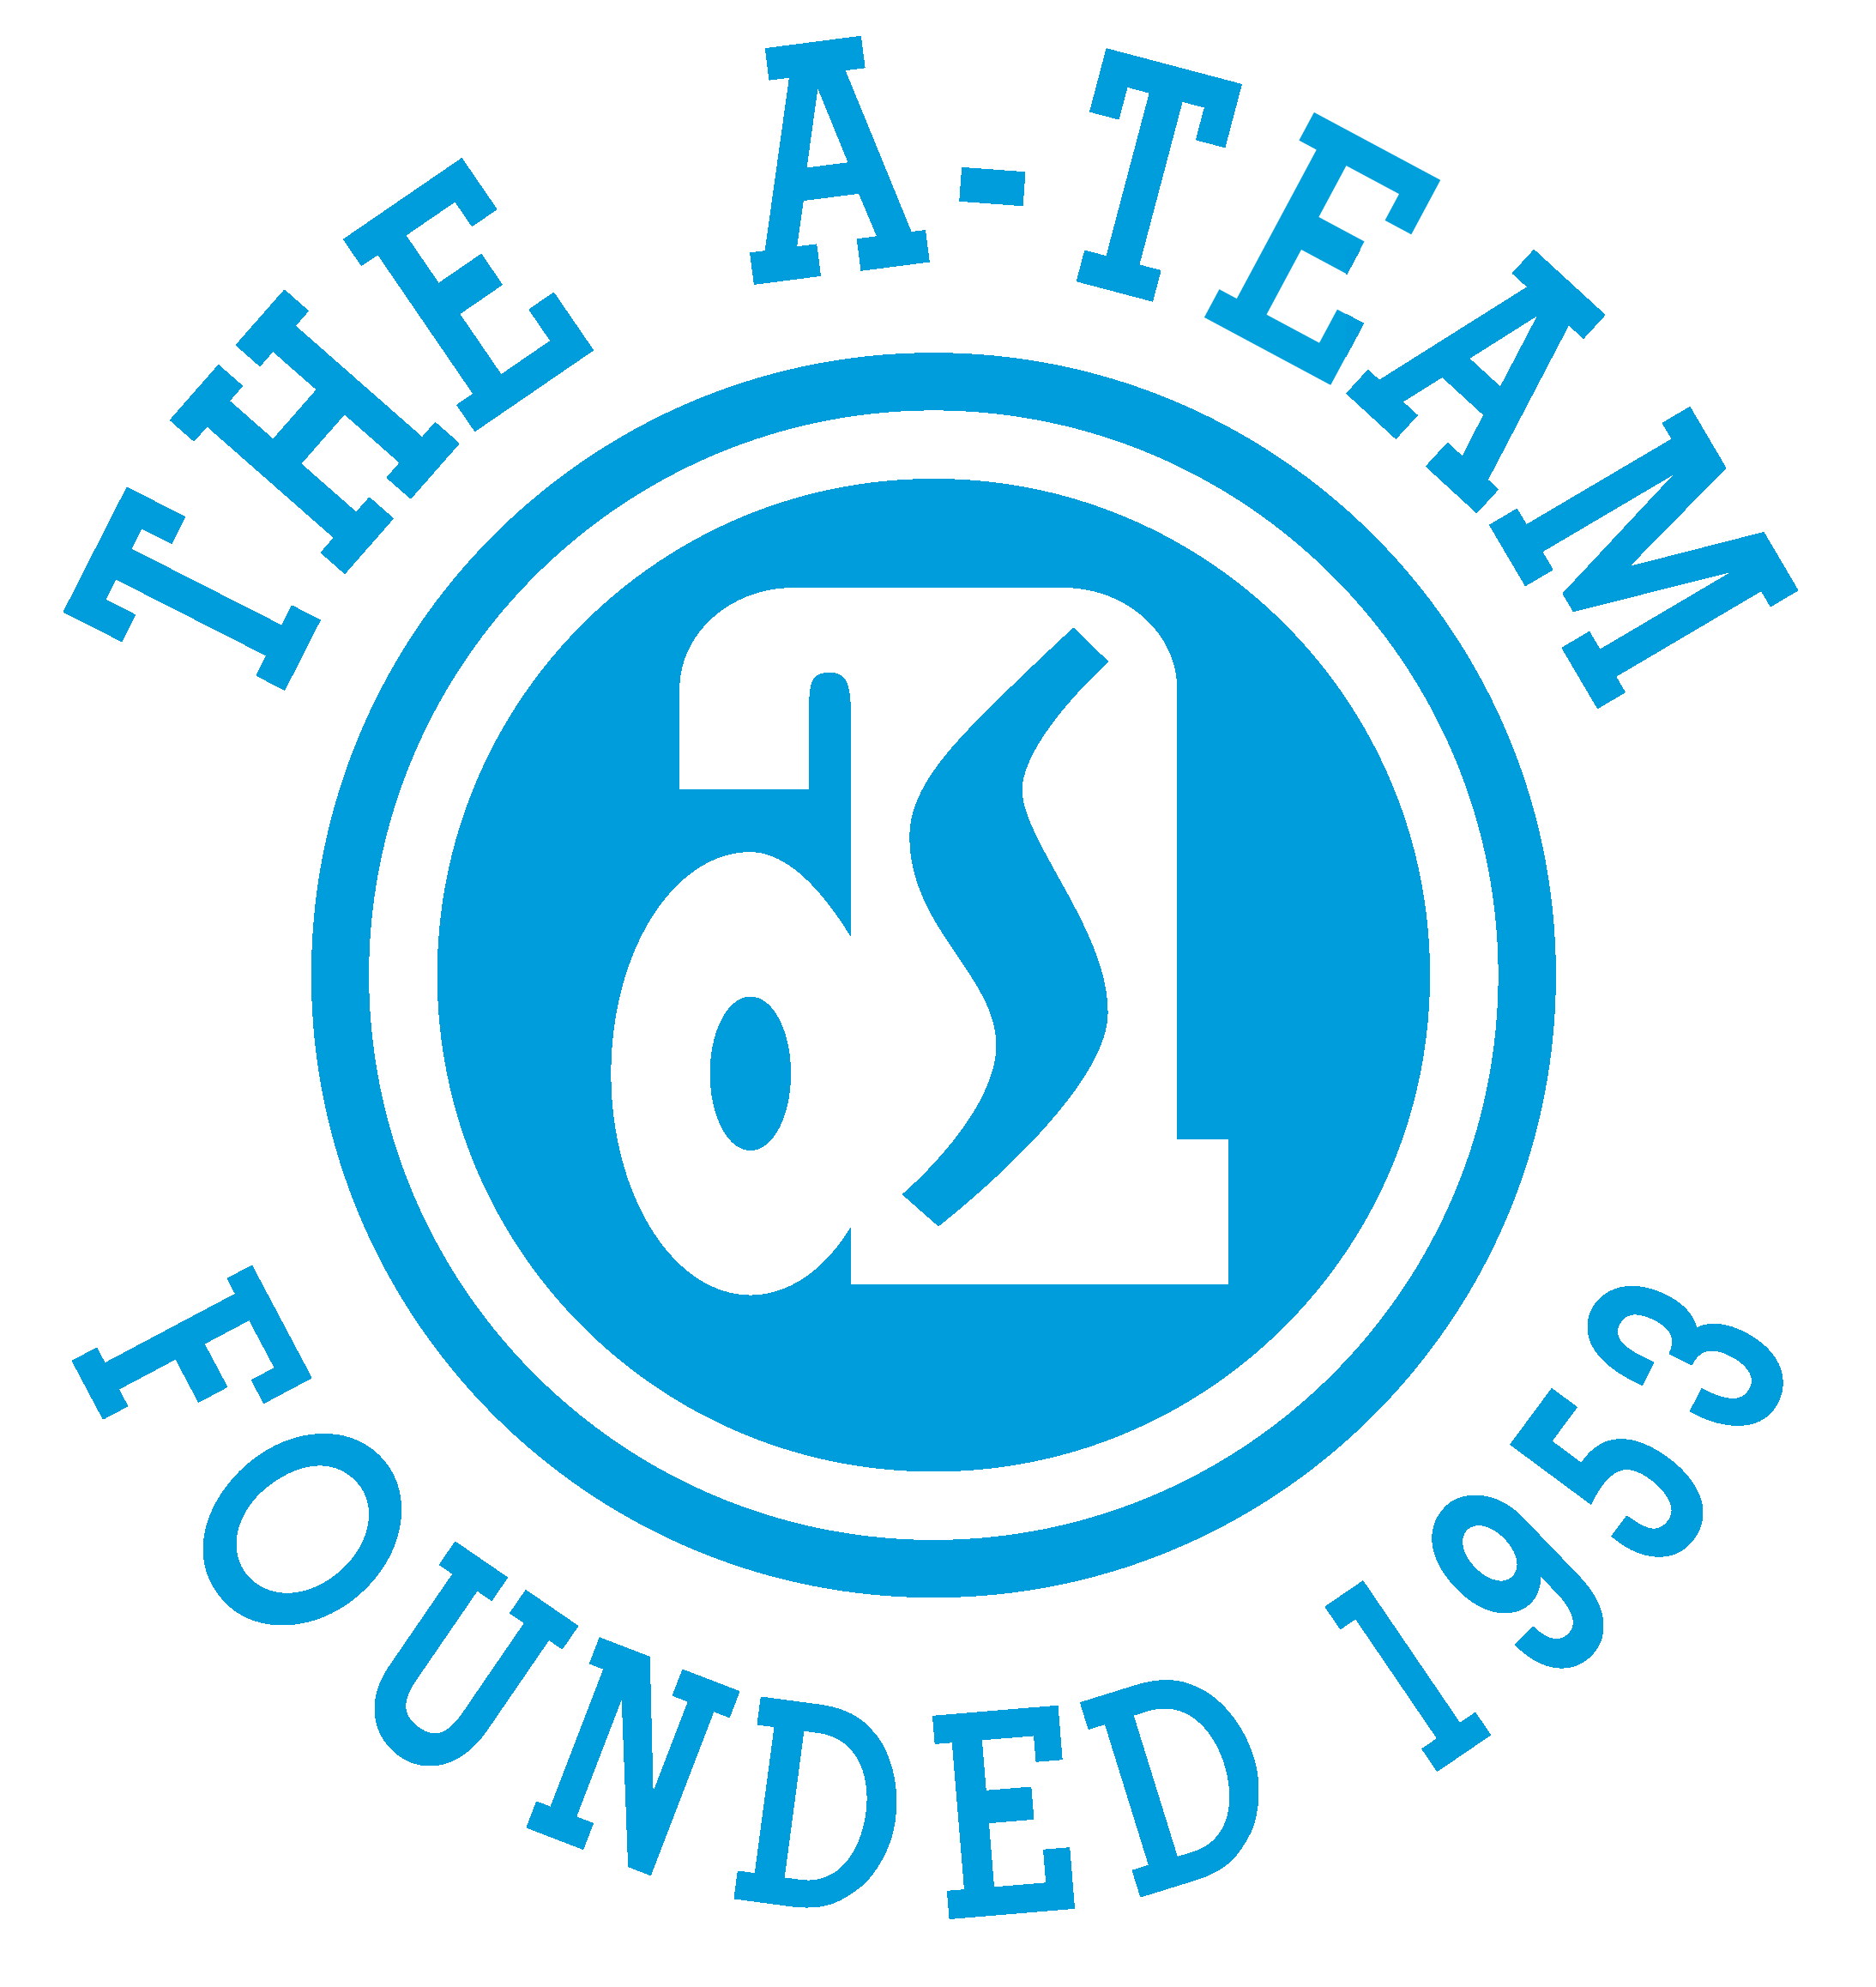

CURRENT INTERNAL JOB POSTINGS

CLICK ON link TO SEE FULL POSTING

UPDATED 6/4/25

- FLEET ACCOUNT EXECUTIVE
Must apply by Friday, June 6th
DISTYLL Graphic Solutions – Adrian, MI
https://bit.ly/4kKUApn

- 2nd SHIFT LASER OPERATOR
Must apply by Monday, June 9th
Adrian Steel Company – Adrian, MI
https://bit.ly/45yQ1dl

- MANUFACTURING QUALITY TECHNICIAN (3RD SHIFT)
Must apply by Wednesday, June 11th
Adrian Steel Company – Adrian, MI
https://bit.ly/4mMVcwy

- DIGITAL CONTENT SPECIALIST
Must apply by Wednesday, June 11th
Adrian Steel Company – Adrian, MI
https://bit.ly/4mLghHF

- TECHNICIAN (3 POSITIONS AVAILABLE)
Must apply by Wednesday, June 11th
Adrian Steel of Ohio – Toledo, OH
https://bit.ly/4dJPZS0

