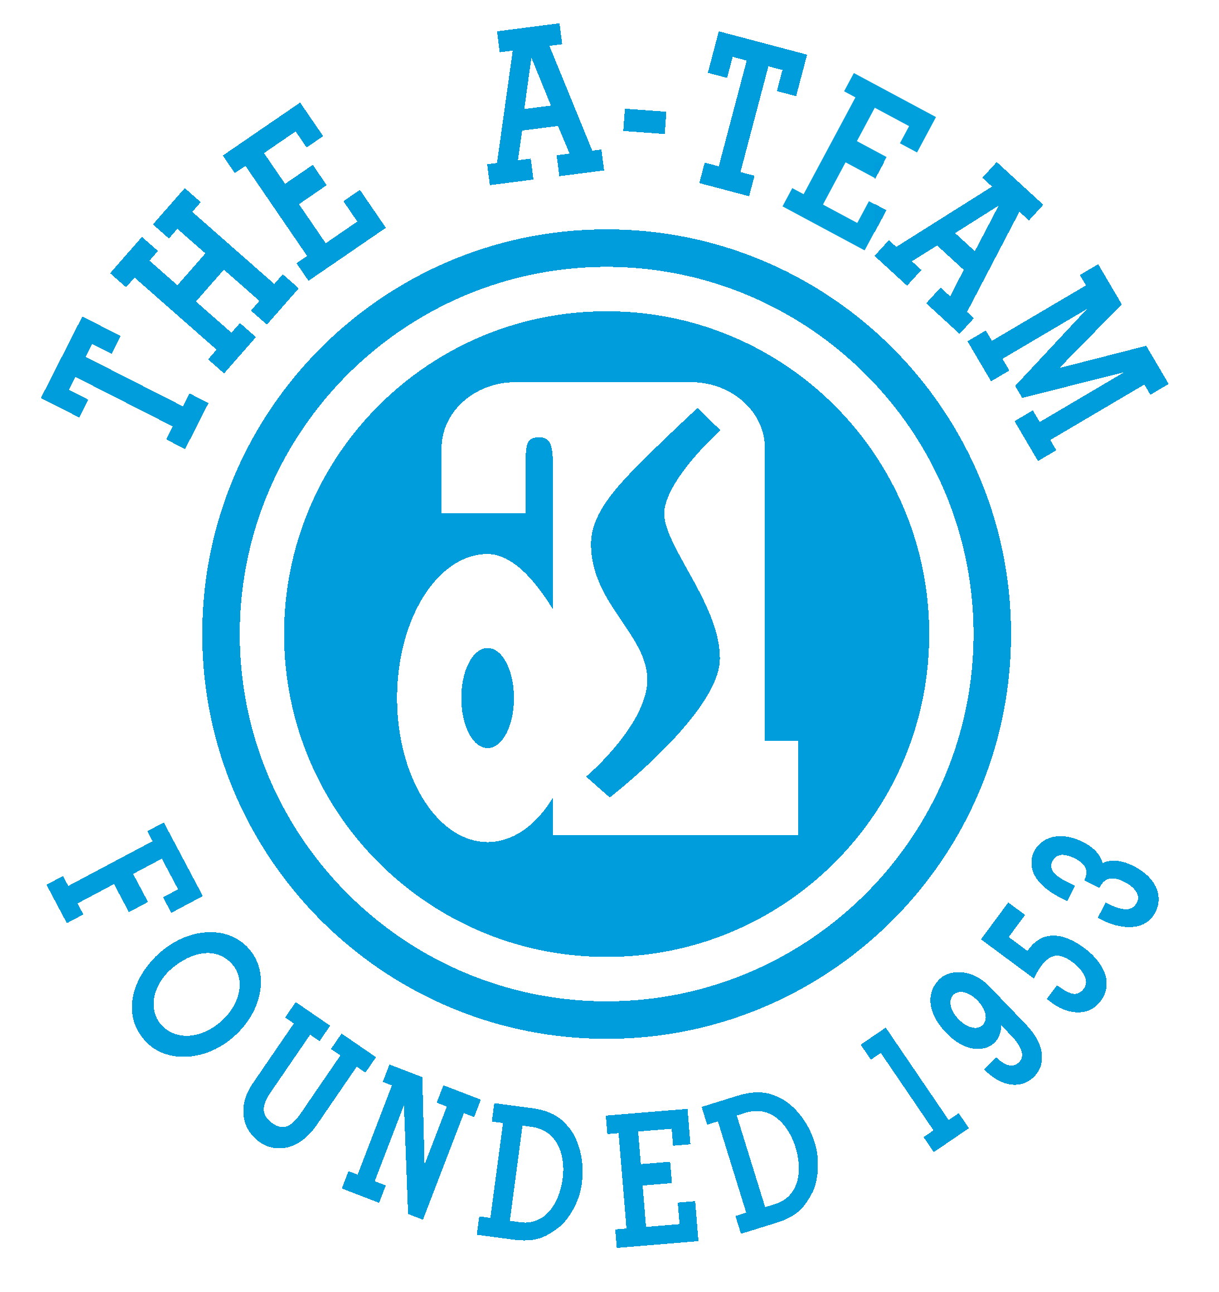

CURRENT INTERNAL JOB POSTINGS

CLICK ON link TO SEE FULL POSTING

UPDATED 7/30/25

- TECHNICIAN
Must apply by Monday, August 4th
DISTYLL Graphic Solutions – Adrian, MI
https://bit.ly/3IPhFJZ

- DESIGN ENGINEER
Must apply by Monday, August 4th
Adrian Steel Company – Adrian, MI
https://bit.ly/4kZBoE8

- ACCOUNTING OPERATIONS ANALYST
Must apply by Wednesday, August 6th
Adrian Steel Company – Adrian, MI
https://bit.ly/4l3Zyx4

- GRAPHIC DESIGN/PRE-PRESS
Must apply by Wednesday, August 6th
DISTYLL Graphic Solutions – Adrian, MI
https://bit.ly/4mED7QD

- PAINTER – SOUTH PAINT LINE (2ND SHIFT)
Must apply by Wednesday, August 6th
Adrian Steel Company – Adrian, MI
https://bit.ly/4lVdueg

